

**Semester One Examination, 2021**

**Question/Answer Booklet**

**MATHEMATICS**

**METHODS**

**ATAR Year 12**

**Section One:**

**Calculator-free**

Student Name: ______________________________________________________

Please circle your teacher’s name

**Teacher: Miss Hosking Miss Rowden**

**Time allowed for this paper**

Reading time before commencing work: 5 minutes

Working time for paper: 50 minutes

**Materials required/recommended for this paper**

***To be provided by the supervisor***

Number of additional

answer booklets used

(if applicable):

This Question/Answer Booklet

Formula Sheet

***To be provided by the candidate***

Standard items: pens (blue/black preferred), pencils (including coloured), sharpener, correction fluid/tape, eraser, ruler, highlighters

Special items: nil

**Important note to candidates**

No other items may be taken into the examination room. It is **your** responsibility to ensure that you do not have any unauthorised material. If you have any unauthorised material with you, hand it to the supervisor **before** reading any further.

**Structure of this paper**

|  |  |  |  |  |  |
| --- | --- | --- | --- | --- | --- |
| Section | Number of questions available | Number of questions to be answered | Suggested working time (minutes) | Marks available | Percentage of examination |
| Section One:  Calculator free | 8 | 8 | 50 | 52 | 35 |
| Section Two:  Calculator-assumed | 13 | 13 | 100 | 98 | 65 |
|  |  |  |  | **Total** | 100 |

**Instructions to candidates**

1. The rules for the conduct of the ATAR course examinations are detailed in the *Year 12 Information Handbook 2021*. Sitting this examination implies that you agree to abide by these rules.
2. Write your answers in this Question/Answer booklet.
3. You must be careful to confine your answers to the specific questions asked and to follow any instructions that are specific to a particular question.
4. Supplementary pages for the use planning/continuing your answer to a question have been provided at the end of the Question/Answer booklet. If you use these pages to continue an answer, indicate at the original answer where the answer is continued, i.e. give the page number.
5. Show all your working clearly. Your working should be in sufficient detail to allow your answers to be checked readily and for marks to be awarded for reasoning. Incorrect answers given without supporting reasoning cannot be allocated any marks. For any question or part question worth more than two marks, valid working or justification is required to receive full marks. If you repeat any question, ensure that you cancel the answer you do not wish to have marked.
6. It is recommended that you do not use pencil, except in diagrams.
7. The Formula sheet is not to be handed in with your Question/Answer booklet.

**Section One: Calculator-free 35% (52 Marks)**

This section has eight (8) questions. Answer **all** questions. Write your answers in the spaces

provided.

Supplementary pages for the use of planning/continuing your answer to a question have been provided at the end of this Question/Answer booklet. If you use these pages to continue an answer, indicate at the original answer where the answer is continued, i.e. give the page number.

Working time: 50 minutes.

Question 1 (6 marks)

(a) Determine $\begin{matrix}d \\ \overline{dx}\end{matrix}\left(\cos^{4}{(x)}\right)$. (2 marks)

(b) Evaluate $f'\left(\frac{π}{2}\right)$ when $f\left(x\right)=\begin{matrix}x+\sin{x} \\ \overline{ \cos{2x} }\end{matrix}$. (4 marks)

Question 2 (5 marks)

A small body is initially at the origin. It is moving along the $x$-axis with velocity at time $t$ seconds given by

$$v\left(t\right)={\left(\frac{t}{2}-2\right)}^{3} \text{cm/s}.$$

(a) Determine $x(t)$, a function for the displacement of the body at time $t$. (3 marks)

The small body is stationary when $t=T$.

(b) Determine the displacement of the body at $T+8$ seconds. (2 marks)

Question 3 (6 marks)

Determine the area of the finite region bounded by $y=\sqrt{2x}$ and $y=\begin{matrix}x \\ \overline{2}\end{matrix}$.

Question 4 (8 marks)

(a) Simplify $\log_{2}{(32)}×\log_{3}{({27}^{2})}$. (3 marks)

(b) Solve for $x$:

1. $\log_{2}{\frac{x}{3}=4}$ (2 marks)
2. $\log_{m}{(x+2)}-\log_{m}{4= \log_{m}{3x}}$ (3 marks)

Question 5 (8 marks)

(a) Sketch the graph of $y=\log_{3}{(x+3)}-1$ on the axes below, clearly showing the location of all asymptotes and axes intercepts. (3 marks)

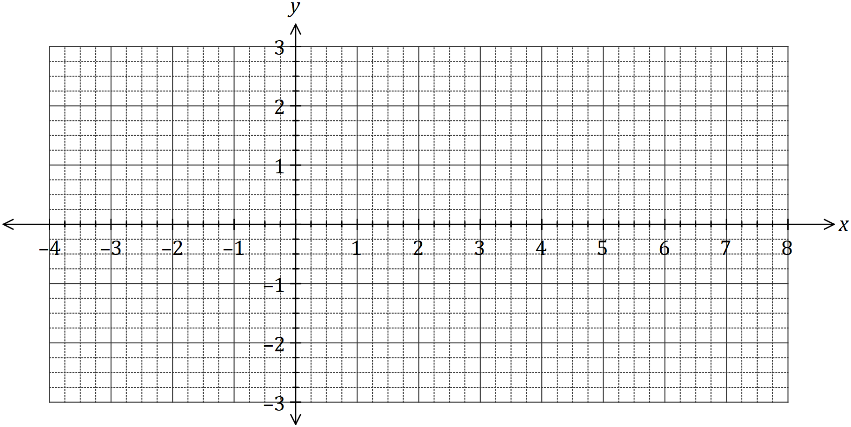

(b) Determine the coordinates of the $y$-intercept of the graph of $y=5\log_{2}\left(x+0.5\right)+1$.

(2 marks)

(c) The graph of $y=\log_{a}{(x+a)}$, where $a>1$, passes through $(6, 2)$. Determine the coordinates of the root of the graph. (3 marks)

Question 6 (5 marks)

(a) Determine $\begin{matrix}d \\ \overline{dx}\end{matrix}\left(3x∙\sqrt[3]{e^{x}}\right)$. (2 marks)

(b) Hence, or otherwise, determine $\int_{ }^{ }{\underset{ }{\overset{ }{\left(3x∙\sqrt[3]{e^{x}} \right)}}}dx$. (3 marks)

Question 7 (6 marks)

The shaded region $R$, shown on the graph below, is bounded by the curve $y=e^{3x}$ and the lines $y=0, x=0$ and $x=a$.

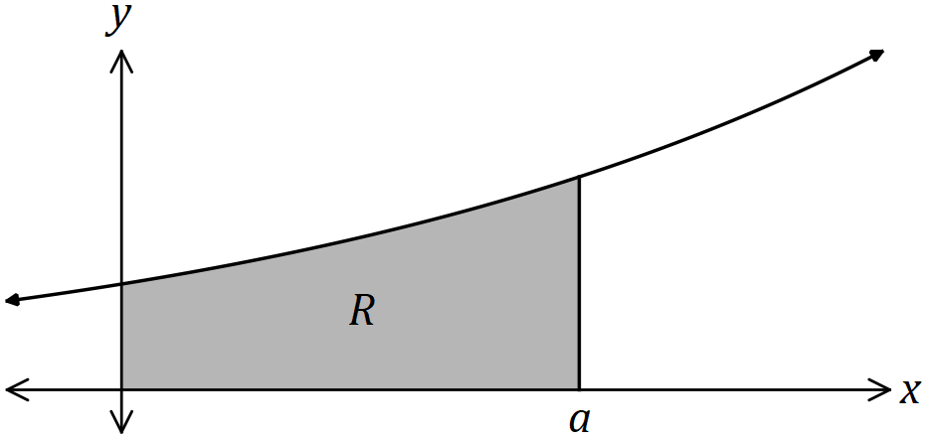

(a) Determine the area of $R$ in terms of $a$. (3 marks)

(b) Determine the value of $a$ for which the area of $R$ is 21 square units in terms of log base 10.

(3 marks)

Question 8 (8 marks)

The function $f$ is defined by $f\left(x\right)=\begin{matrix}4 \\ \overline{x^{2}+12}\end{matrix}$, so that $f^{''}\left(x\right)=\begin{matrix}24(x^{2}-4) \\ \overline{ {\left(x^{2}+12\right)}^{3} }\end{matrix}$.

(a) Describe the concavity of the graph of $y=f(x)$. (4 marks)

(b) Determine, with justification, the range of $f'(x)$. (4 marks)

Supplementary page

Question number: _____________________

Supplementary page

Question number: _____________________